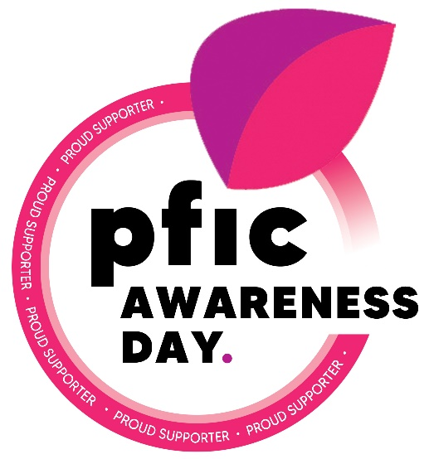

Fundraising Toolkit
Virtual, In person or Community Partnership

Hello PFIC warriors, ambassadors, parents and supporters.
This year our PFIC awareness day hashtag is #itchingforacure. As we come together as a community to support those who itch, we will plant seeds that will leave an impact for years to come.

Thank you for your interest in hosting a fundraiser to support the PFIC network on October 5, 2021. Our board of directors, volunteers and families appreciate your support in making this day a success.

Our annual PFIC Awareness Day is consistently the highlight of the year for our organization. We hope to raise $30,000 so that we can guarantee the full operation of our website, peer support, advocacy and research programs for the entire next year. So we need your help!

We want to make it simple and easy for you to raise awareness and fundraise for PFIC.
As easy as: 1. 2. 3.
- Raise Awareness
- Fundraise
- Give Thanks
We are excited to support and supply you with a fundraising toolkit that will help you do all three steps and more! You just need to decide your platform. Virtual? In person? Or Community driven?

Please remember, although our goal is to raise funds and awareness for the PFIC Network, we want everyone to be safe and enjoy a fun day together as a family.

CHOOSE YOUR FUNDRAISING PLATFORM!

In the past, we have encouraged all participating families to host a lemonade stand or something similar and invite their family and friends to support. In light of the COVID-19 pandemic, we want you to take the necessary steps that you need to in order to be safe and comfortable. That is why we have created 3 options for you. Our fundraising toolkits will equip you no matter what platform you choose.
NEXT STEPS
After you review the platform options for your fundraising awareness event, please contact us with any questions. If you need more inspiration, clarification, or information, let us know and we can help you plan a Fundraiser that works well for you!
Remember to share your success—we want to see your photos! With your permission, we will share your photos to our social media accounts. Additionally, we plan to use photos that have been shared with us (or that we were tagged in) to put together a special gift for those in our community for our end of the year wrap up.

Helpful information

Organization Name: PFIC Network, Inc.
Organization Mailing Address: PO Box 551, Stanton KY 40380, USA
Federal Tax ID (EIN): 83-1084501

Website: www.pfic.org

Awareness Day Fundraising Tool Kit Contact: Lisa Crompton (lisa@pfic.org)

Thank you again for your commitment to helping support the PFIC Network.
Together, we are #itchingforacure!

The PFIC Network Team
Emily Ventura, Melanie Karakaidos, Tara Kearns, Lisa Crompton, Hayley Watts, Walter Perez., Erin Hovey, Charmaine Gravener, Tyler Bradley

IN PERSON FUNDRAISER
If you choose to host an in-person fundraiser you can do whatever is right for you! In the past, we have seen lemonade stands, hot chocolate stands, bake sales or garage sales. If you choose this option, please remember to follow all health regulations that are in place in your city.
Remember we want to make it as easy as 1-2-3!
- RAISE AWARENESS
- Decorate and take ownership of your stand, table or area.
- Display your toolkit logo gear front and center and encourage people to take a piece of gear!
- Take photos of your fundraiser! Share them within your circle and send them to us so we can share and display your work!
- Educate those around you. Use the brochures that are in your toolkit to talk about PFIC. Direct your friends and family to our website! www.pfic.org A lot of hard work has gone into our website and we are proud of the wealth of information you will find.
- Share your PFIC story with pfic.org or other avenues such as www.pficvoices.com. Direct your friends and family to these sites so they can hear the story of others within the PFIC family.

- FUNDRAISE
- Collect donations during your fundraiser! If anyone asks how the donations are used, please share the mission of the PFIC Network “To improve the lives of patients and families with PFIC worldwide.” A great example of how donations are used is our peer support programs, which can be found at www.pfic.org/pfic-network-programs
- Direct anyone who would like to give and support online or with credit card to www.pfic.org and click the DONATE button.
- Anyone who wishes to send donations directly to the PFIC Network can send them to:
PFIC Network, Inc.
PO Box 551
Stanton, KY 40380

- GIVE THANKS
- Remember to express gratitude wherever you can. The success of this day comes from the community that comes together to give together.
- Share the supplies in the kits such as pens and stickers.
- Give out the prewritten thank you letter included in your kit. If in the US, this letter can be used for tax deduction purposes.
- Send us the name of any donors who wish to be acknowledged in our newsletter!
- Send us your T-Shirt size so that we can send you a color T-shirt as OUR thank you to YOU!

VIRTUAL FUNDRAISER
Get social with us! This is a great opportunity to expand our impact with a few clicks that day.
- RAISE AWARENESS
- Connect on social media by using the hashtag #itchingforacure.
- Like and Share our posts on our Facebook page “PFIC Advocacy and Resource Network” or our Instagram and Twitter pages @pficnetwork.
- Change your profile pictures to the PFIC Awareness day profile picture frame.
- Share pictures of you or your loved ones wearing your PFIC or Rare Disease T-shirts
- Email your friends and family and share our digital brochures, website and pictures.
- Share your PFIC story with pfic.org or other avenues such as www.pficvoices.com. Direct your friends and family to these sites so they can hear the story of others within the PFIC family.
- Let us know when you share your story so that we can plan to share on our pages and promote your campaign.

- FUNDRAISE
- Share our fundraising goals on social media.
- Share the link to our PFIC Awareness Day event site, www.events.pfic.org
- Share the website www.pfic.org/donate as a place to give. Remember to highlight if someone gives $20 or more during the PFIC Awareness Day campaign then they will receive a piece of logo gear as a thank you!
- Remember to keep an eye out for match incentives that may come available!

- GIVE THANKS
- Send out the thank you letter to all who support your fundraiser.
- Give thanks on social media when PFIC Awareness Day is done!
- Send us the names of any donors who wish to be acknowledged in our newsletter!

COMMUNITY DRIVEN FUNDRAISING EVENT
Do you have a business or are you closely connected with a community business who may be interested in supporting the cause?
1. RAISE AWARENESS
- Reach out! Share your story and your passion to the cause.
- Share the cover letter provided in this toolkit: PFIC Network, Who We Are
- Provide the logo gear to the partnering business to display at their register or with their patrons however they see fit.
- Take photos of your partnership. Share them within your circle and send them to us so we can share and display your work! When sharing, make sure to include any hashtags, websites or information about your partnering business as a returned favor.
- Educate those around you. Use the brochures that are in your toolkit to talk about PFIC. Direct patrons to our website www.pfic.org! A lot of hard work has gone into our website, and we are proud of the wealth of information you will find.

- FUNDRAISE
- Place a donation jar with your community partner! Make a sign for your jar to explain the cause! If anyone asks how the donations are used, please share the mission of the PFIC Network “To improve the lives of patients and families with PFIC worldwide.” A great example of how donations are used is our peer support programs, which can be found at www.pfic.org/pfic-network-programs
- Ask your community partner to donate a portion of proceeds on PFIC Awareness Day to the PFIC Network.
- Direct anyone who would like to give and support online or with credit card to go to www.pfic.org and click the DONATE button.

- GIVE THANKS
- Remember to express gratitude wherever you can. The success of this day comes from the community that comes together to give together.
- Share the supplies in the kits such as pens and stickers.
- Give out the prewritten thank you letter included in your kit. If in the US, this letter can be used for tax deduction purposes.
- Send us your T-Shirt size so that we can send you a color T-shirt as OUR thank you to YOU!
- Send us the T-shirt size of your partner so we can send a color T-shirt to them as well!
- Send us your partners logo or website so that we can give thanks in our newsletter!

YOUR PFIC DAY LEMONADE STAND TOOLKIT
FUNDRAISING TOOLKITS  (In person and Community)  - T-Shirt (for you!)  - 20 Stickers  - 10 Keychains  - 20 Pens  - 20 Thank You Cards  - 5 PFIC Network Brochure  (digital file available upon request)  - 5 Talk to your Doc Brochure  (digital file available upon request) | VIRTUAL TOOLKITS  - T-shirt (for you!)  - 5 stickers  - 3 Keychains  - 10 Pens  - Digital Thank you Card  - 1 PFIC Network Brochure + digital file  - 1 Talk to your Doc Brochure + digital file  - 1 PFIC Educational Brochure + digital file
